Name:_________________________________________

Teacher: _______________________________________

Class: ____________________________

CC Number: _____________________________

MATHEMATICS

YEAR 10 EXAM
PATHWAY TWO
Section One: Resource-Free

TIME ALLOWED FOR THIS PAPER
Reading time before commencing 5 minutes.
Working time for paper 45 minutes.

MATERIAL(S) REQUIRED / RECOMMENDED FOR THIS PAPER
TO BE PROVIDED BY THE SUPERVISOR:
This Question / Answer Booklet
Formula Sheet

TO BE PROVIDED BY THE CANDIDATE:
Standard items: pens, pencils, pencil sharpener, eraser, correction fluid, ruler, highlighters.

Special items: nil

Important note to candidates: No other items may be used in this section of the examination. It is your responsibility to ensure that you do not have any unauthorised notes or other items of a non-personal nature in the examination room. If you have any unauthorised material with you, hand it to the supervisor before reading any further.

Instructions to candidates
- Candidates are to remain seated during the exam and are not allowed to talk to other candidates.
- Mobile phones are not to be used at all during the exam.
- Students who fail to follow examination rules will be removed and dealt with in accordance to the schools policy.

Write your answers in the spaces provided in this Question/Answer Booklet. Spare pages are included at the end of this booklet. They can be used for planning your responses and/or as additional space if required to continue an answer.
- Planning: If you use spare pages for planning, indicate this clearly at the top of the page
- Continuing an answer: If you need the space to continue an answer, indicate in the original answer space where the answer is continued, i.e. give the page number. Fill in the number of the question(s) that you are continuing to answer at the top of the page.

Show all your working clearly. Your working should be sufficient to allow your answers to be checked readily and for marks to be awarded for reasoning. Incorrect answers given without supporting reasoning cannot be allocated any marks. For any question or part question worth more than two marks, valid working or justification is required to receive full marks. If you repeat an answer to any question, ensure that you cancel the answer you do not wish to have marked.

Use a blue or black pen only, except with diagrams where you should use pencil.

Question | Out of | Mark
1 | 3
2 | 1
3 | 1
4 | 1
5 | 1
6 | 1
7 | 1
8 | 1
9 | 2
10 | 1
11 | 2
12 | 7
13 | 5
14 | 6
15 | 8
16 | 4
TOTAL | 45
 | Mark
Percentage

- Use words from the list below to complete the following sentences. (Hint: There are more words than needed).

equation, expanding, multiplying, coefficient, expression, like terms, variable, constant, substitution, replacement

- 3y + 7 is called an ___Expression___.

- The letter y in 3y + 7 is called a _variable_.

- The number 7 in 3y + 7 is called a ___constant__ and the number 3 is the ___coefficient _.

- When we replace a with a certain number, this is called _____Substitution_.

- To simplify 4e + 3f − 2e + 6f we collect _____Like terms____. The expression then simplifies to 2e + 9f.
($\frac{1}{2}$ each)
(3 marks)

- Evaluate 3−4. (Choose the correct answer)

A −12 B −81 C D

(1 mark)

- Simplify 43 × 45, leaving your answer in index form. (Choose the correct answer)

A 48 B 415 C 168 D 1615

(1 mark)

- Simplify (3ab x 2a3b)2. (Choose the correct answer)

A 6a8b4 B 36a8b4 C 6a6b4 D 36a6b4

(1 mark)

- Which measures are used in the five number summary? (Choose the correct answer)

A Mean, median, range, lower quartile, upper quartile

B Mean, median, mode, lower quartile, upper quartile

C Minimum, maximum, median, lower quartile, upper quartile

D Minimum, maximum, mean, median, mode

(1 mark)

- Which measure of central tendency should you use if you want to find the typical income in a suburb? (Choose the correct answer)

A the mean B the median C the mode D the range

(1 mark)

- How would you describe the following scatter plot? (Choose the correct answer)

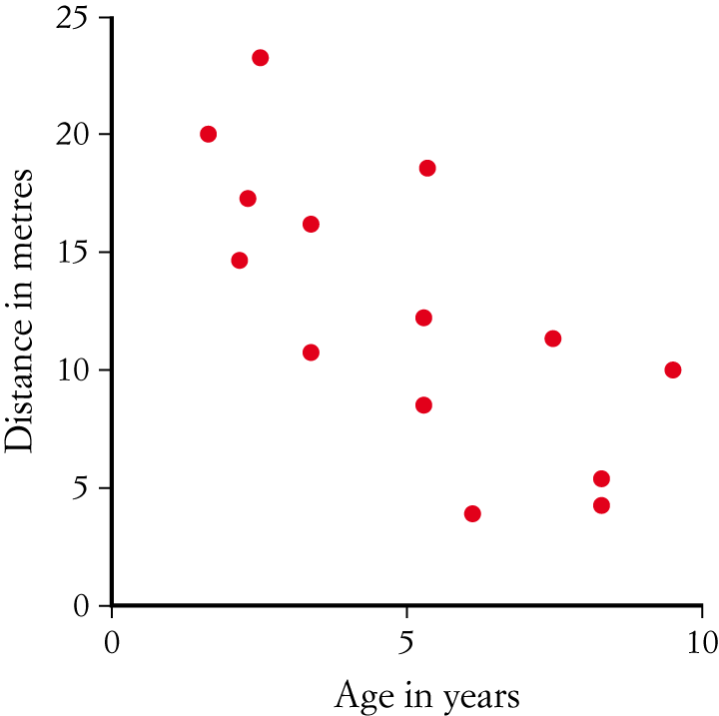

A Strong positive relationship

B Weak positive relationship

C Strong negative relationship

D Weak negative relationship

(1 mark)

- Simplify p2 + 3pq − qp +2p2. (Choose the correct answer)

A 3p2 + 3pq − qp B 3p2 + 3

C p2 + 3pq − qp + 2p2 D 3p2 + 2pq

(1 mark)

- Alpha Centauri is 9 460 000 000 000km from the sun. Write this distance using scientific notation and express how many significant figures are in the number.

$9.46×{10}^{12}$

Three sig figs
(2 marks)

- An atom of Palladium has a diameter of $1.69 ×{10}^{-7}$mm. Write this using standard notation.

0.000 000 169

(1 mark)

- Simplify the following, leaving your answer in index form.

- 9p2q5 ÷ 27p6q5

$$\frac{1}{3p^{4}}$$
or
$$\frac{1}{3}p^{-4}$$

(2 marks)

- Expand and simplify:

- $-5\left( x+2 \right)=-5x-10$

- $2\left(3x-5\right)+4\left(5x+1\right)-\left(x+2\right)=6x-10+20x+4-x-2 =25x-8$

- $2x\left(3x-y+5z\right)-10y\left(5x+2y-z\right)=6x^{2}-2xy+10xz-50xy-20y^{2}+10yz$
$=6x^{2}-52xy+10xz+10yz-20y^{2}$

(7 marks)

- Two PE classes of students have their pulse rates (in beats per minute) measured.
The results are shown in these box plots.

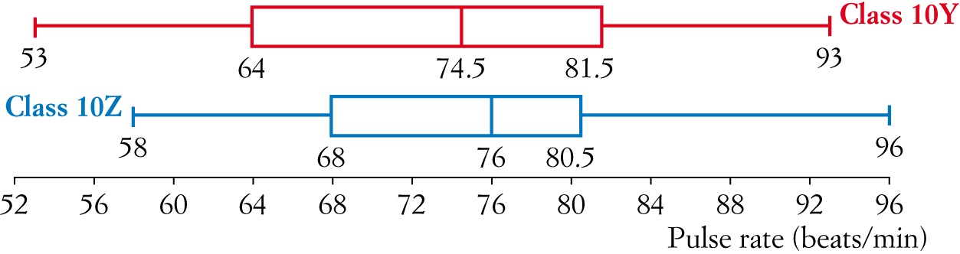

- What was the lowest pulse rate across both classes?
53

- Find the interquartile range for class 10Z.
12.5

- If there are 24 students in class 10Y, how many had a pulse rate between 74.5 and 81.5?
6

- Which class had the higher pulse rate on average? How does the box plot show this?
10Z – Highest median

- Which class had more spread of pulse rates? How does the box plot show this?
10Y – Biggest range

(5 marks)
- Factorise the following expressions:

- $24x+6=6(4x+1)$

- $-55k-10=-5(11k+2)$

- $x+ 5x+6=(x+2)(x+3)$

- $x^{2}-36=(x-6)(x+6)$

(6 marks)

- Simplify:

$$=\frac{14c}{15}$$

$$\frac{4x+6-3x-15}{12}=\frac{x-9}{12}$$

- $\frac{2g}{3}×\frac{gh}{8}$

$$=\frac{g^{2}h}{12}$$

- $\frac{3h+5p}{5}÷\frac{9h-8p}{7}$

$$=\frac{3h+5p}{5}×\frac{7}{9h-8p}=\frac{21h+35p}{45h-40p}$$

(8 marks)

- Expand and simplify the following.

  - $\left(2y-3\right)\left(y+1\right)=2y^{2}-y-3$

  - $\left(a+6\right)-3\left(2a+1\right)=3-5a$

(4 marks)
End of Paper
Additional working space

